**Style Guide**

Style guides provide the necessary information to continue a digital project once the administration is handed over to the client. Styles are primarily defined as a guide to the design of styles, however they are also useful to designers when creating elements that are not part of the templates above, as they are bounded by standards that have already been chosen.

**Logo:**

the design of the logo was the following:

**Color Palette:**

|  |  |
| --- | --- |
|  |  |
| **color** | **Color** |
| * #20a0dc | * #7f7a7a |
| * #ffffff | * #757575 |
| * #dadce0 | * #fcfcfc |
| * #74cffa | * #ececec |

**Fonts:**

It is a list of the types of fonts present in web design. In addition, it explains all the rules that will govern the use of these fonts on the site, including names, sizes, styles, and colors. It is convenient to attach images that illustrate all these details to avoid confusion.

|  |  |
| --- | --- |
| **main menu** | font-family: tahoma, arial, helvetica, sans-serif;  font-size: 15px;  padding: 10px 25px;  color: #757575;  display: block; |
| **Section title** | display: flex;  justify-content: left;  color: #20a0dc;  font-size: tahoma;  font-size: 20px;  padding: 20px; |
| **Text Inside** | color: #ececec;  font-size: 12pt;  font-family: sans-serif;  padding-right: 150px;  line-height: 1.5em; |
| **H1** | font-size: 20pt;  font-family: sans-serif;  padding: 20px;  text-align: justify;  color: #20a0dc; |
| **Footer text** | display: flex;  flex-direction: row;  justify-content: space-between;  padding-left: 20px;  padding-right: 20px;  color: #20a0dc;  font-family: sans-serif;  font-size: 13px; |







**Main Banner:**



**Inside Banners:**

**Button styles and/or navigation elements:**

Defines the combined use of fonts with the color palette. It must show how the buttons and links will look, considering the uses with and without text, on hover, selection and inactivity.

Applications in navigation elements are also described, showing the layout of scroll arrows, breadcrumbs, menus, and submenus.

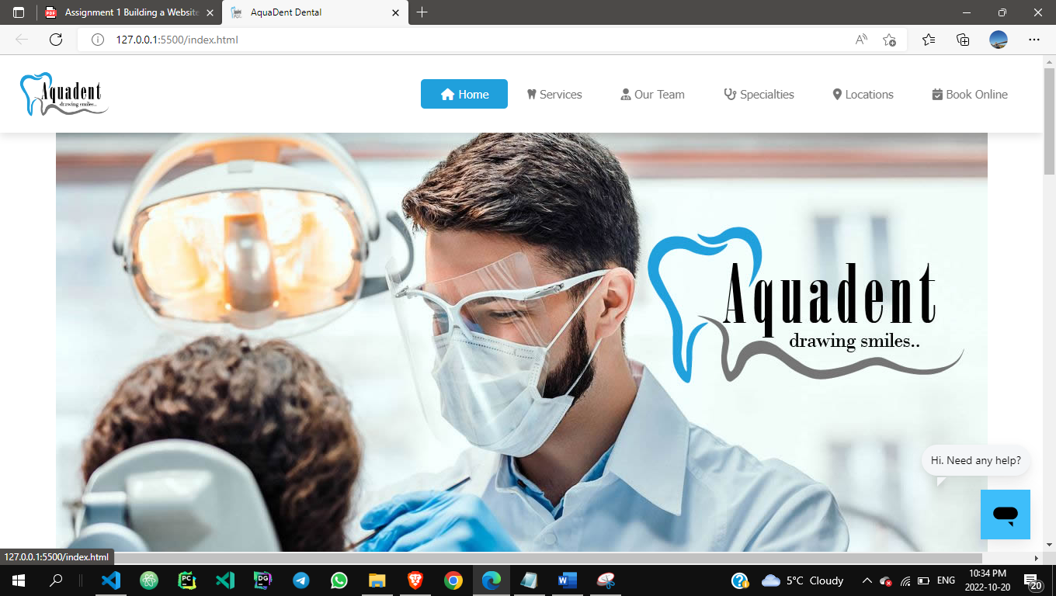

**FINAL MOCKUPS:**

**Landing Page:**

**Menu: Book Online.**

**Menu: Locations**

**Menu: Specialties**

**Website Map:**